Q5:

1_ start with the VBR and getting the MFT LCN by the structure of the VBR:

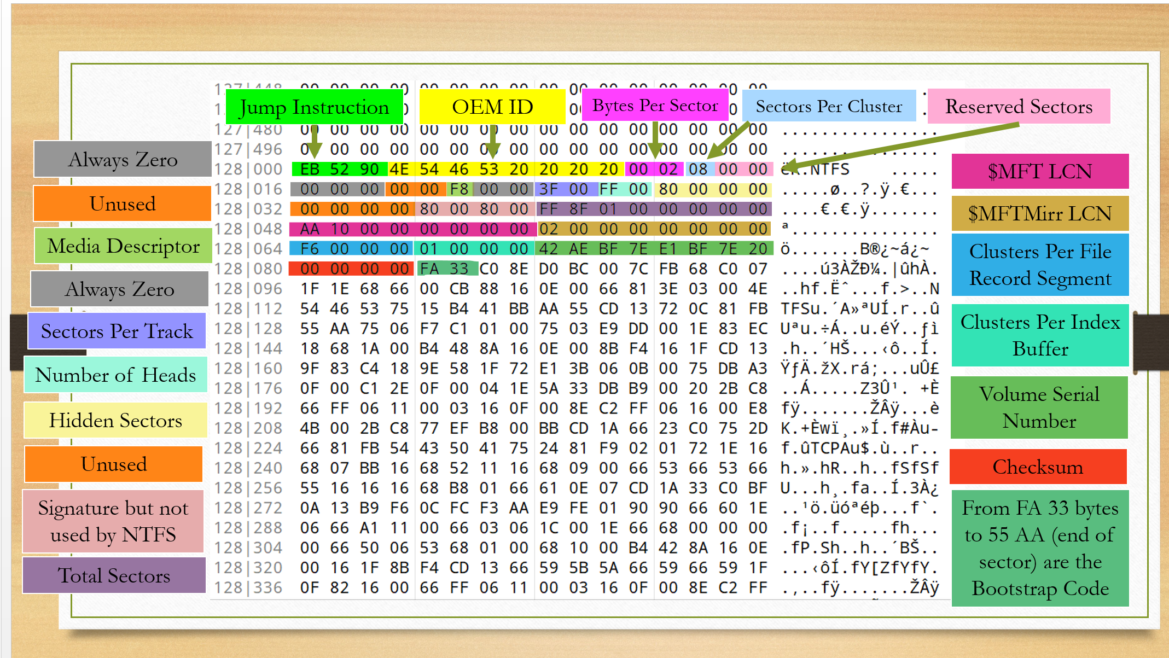

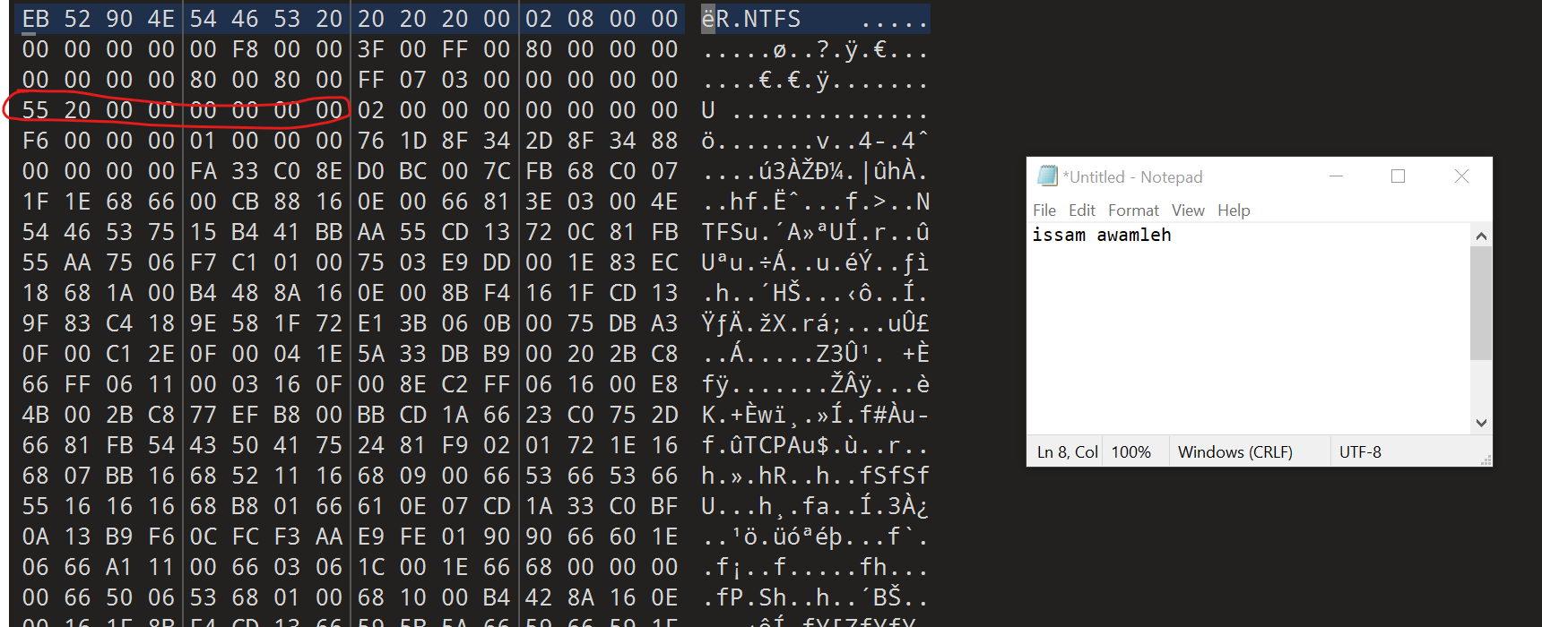

2_ after taking the MFT LCN which is (55 20 00 00 00 00 00 00) we need to convert it to big endian:

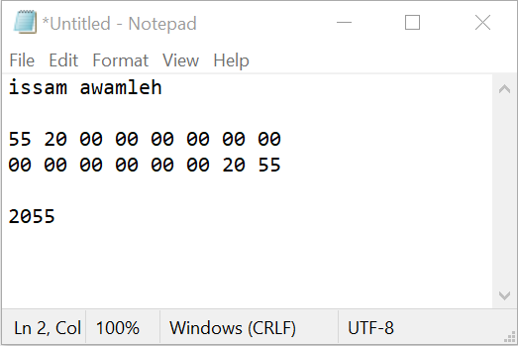

3_ taking it to the calculator to convert because we got it in clusters and to have it in sector we need to multiplicities it with this (which is the sectors per cluster):

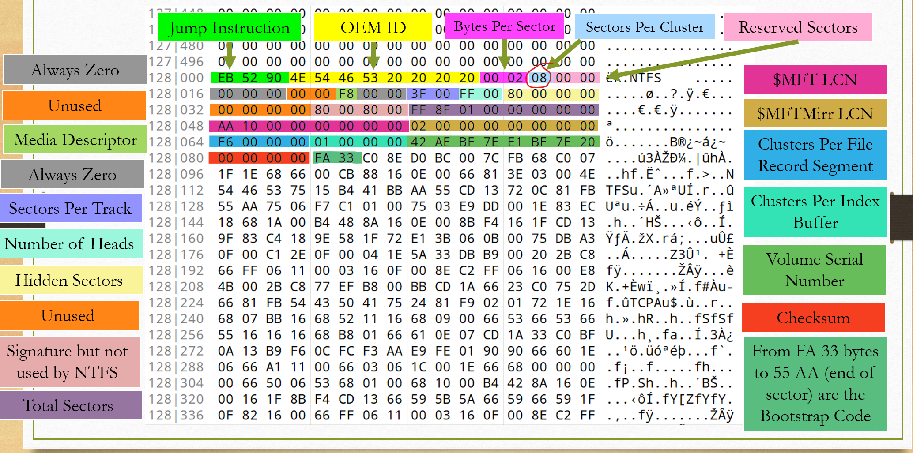

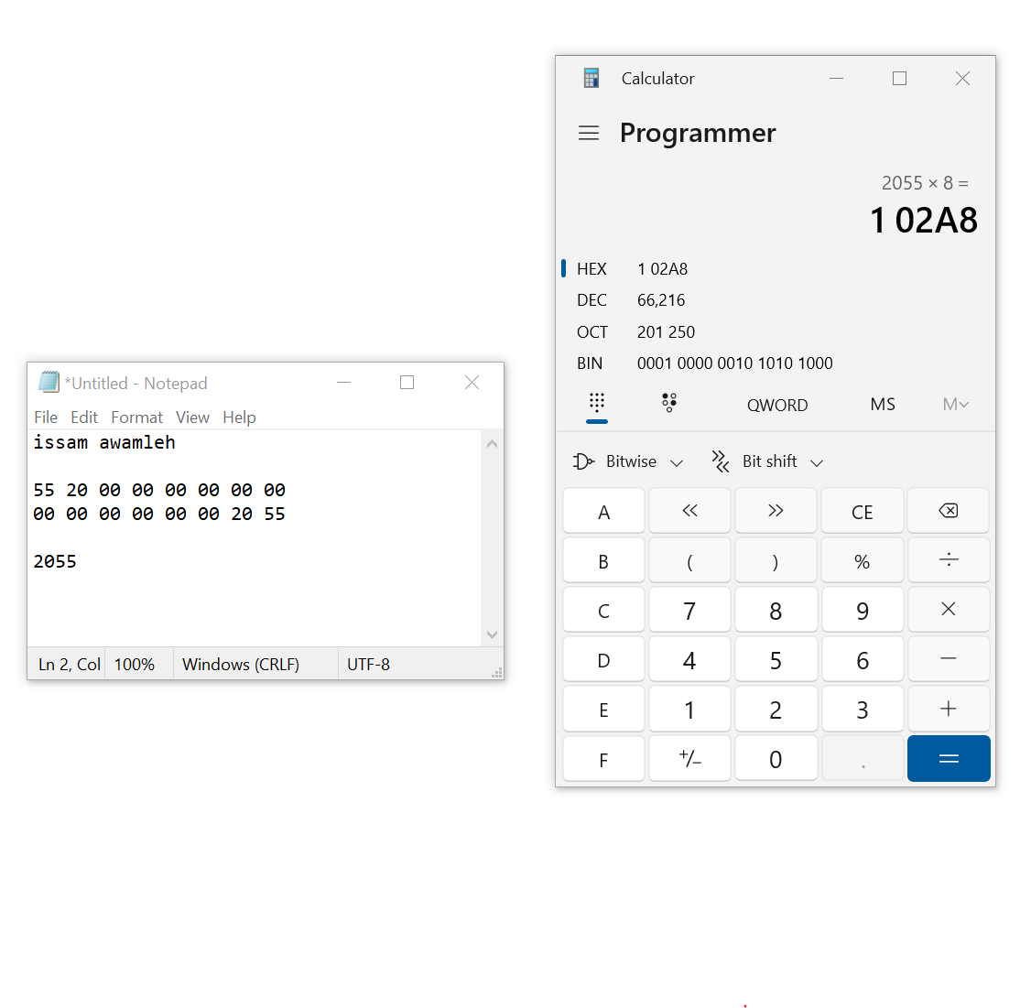

4_ after that we move from VBR to MFT by moving (102A8) from the beginning of the VBR:

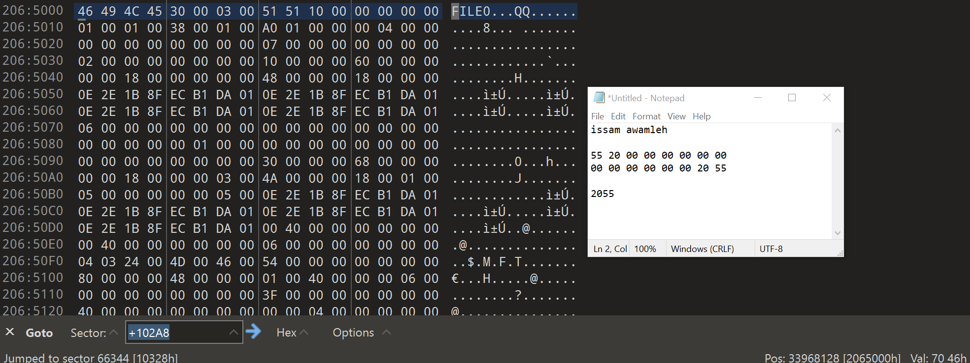

THE ANSWER IS : 102A8